Six days of Christmas: Christmas with conservative grandmother had a slithery side: Reptiles fill granddaughter's holiday memories
Saturday, December 24, 2011

EDITOR'S NOTE: This is one in a series of Foster's Daily Democrat's annual Six Days of Christmas stories. This year's theme was Christmas memories with grandparents. Nancy Sposato says no one would ever guess her grandmother's house was full of dangerous reptiles. She dressed conservatively and even wore a pearl necklace.
My grandmother (on my mother's side) lived with my aunt (mom's older sister). They lived in the Boston area all their lives and were big researchers of our family genealogy. Both my grandmother and my aunt could usually be found wearing a conservative dress with high heels and a pearl necklace. They were ladies, of course. They, along with my mom, were always quick to correct us when we used improper grammar. Christmas dinners were always rich with conversations of what their lives were like as children and, of course, where we come from genealogically speaking.
(My grandmother was born in 1896.) My grandmother also owned a reptile zoo/gift shop.
She had many types of reptiles over the years, especially large snakes, several of which were poisonous. She used to keep her snakes in special cages in her indoor/outdoor heated porch. We used to drive to my grandmother's home for Christmas and have an overnight visit each year. She lived in a roomy Victorian home decorated with too much furniture, African masks hanging on the walls, and antique dolls staring at you wherever you went, not to mention all the reptiles.
Upon arrival one Christmas, as I entered the kitchen, I noticed a covered laundry basket sitting in the very center of the room. My grandmother and aunt were hustling and bustling around the kitchen trying to prepare the Christmas dinner. Even though I was only about 8 years old at the time, I always knew to ask when I saw something unusual at my grandmother's house. Just as I started to ask the question, "Why is there a laundry basket sitting in the middle of the kitchen floor?" my grandmother interrupted saying, "Don't open that! The boa's in there; we're cleaning his cage. He was too heavy for just the two of us to lift so we thought we'd wait for your father to arrive so he could help."
So there sat the laundry basket with the boa constrictor in it while we ate our turkey dinner. After dessert I got to watch my father, aunt and grandmother struggle to take the boa out of the laundry basket (as he weighed quite a bit) then again struggle to carry him through the kitchen and out onto the porch to his cage. You see, the boa was (at that time) one of the longest living in captivity. He was huge and many feet long. His massive weight made it very difficult to carry, especially when he kept moving. The image is seared into my memory as both my aunt and my grandmother battled the boa while dressed in their high heels, conservative dresses, aprons tied around their waists, and wearing their pearl necklaces.
It was, after all, Christmas. One must dress up. When that job was done, we retired to the parlor to open presents. That was the year Santa had brought me my long awaited blonde wig. I always wanted to have long hair and now I could. The wig had a tiny pink bow in the center and made me look like a blonde Cher. Unfortunately, that was the same year Santa brought a train set to my brother. We soon discovered that wigs and train tracks don't mesh. Long pieces of blonde hair kept jamming the wheels of the train. Poor Bobby. Oh, well, at least I had my wig.
Nighttime at my grandmother's (upstairs) was a whole different story. Yes, the snakes were downstairs on the porch but upstairs, in the Victorian tub, was her alligator. When I awoke at night needing to use the bathroom, I would have to tiptoe to my parents' room, wake my mother up, and have her escort me to the bathroom. After all, when you're a little kid, it's scary having an alligator stare at you. When I expressed concern about it my mother would say, "Oh, Nancy, don't worry about him. He won't bother you. Just hurry up and go." If my mother wasn't phased, then apparently I shouldn't be either.
That was the message. After all, she grew up with all that and more as a child. She must know what she's talking about, right?
During these visits, I used to like to go onto the porch and look at all the snakes, etc. I liked to try sneaking past the rattlesnake cage w/out him knowing I was there. But every time I did, even if I ducked down below the level of the cage, he knew I was there and shook his rattle anyway. Every time.
That was the kind of entertainment I enjoyed at Christmas and other times when visiting my grandmother. I always knew it wasn't a normal life ... but it was normal for us. No cookies were ever baked by her, but many memories were made just the same. That was Christmas at my grandmother's.
I'm hoping, even if you aren't able to use this story, that you'll enjoy it as much as I enjoyed remembering it. It was many years ago, and all of them are gone now. I miss them very much and feel very blessed to have such great memories.
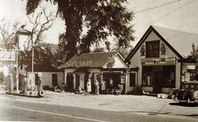

A picture of gas station, gift shop and reptile zoo owned by Nancy Sposato's grandmother Eugenia Shorrock in Alton Bay in Febuary, 1952's.

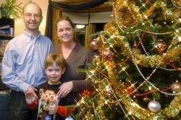
John Huff/Staff photographer John, Nancy and Kenny Sposato stand by their Christmas tree at their Dover home recently. Nancy tells of spending Christmas at her grandmother's house in Massachusetts where she kept the reptiles from Reptile Zoo in Alton Bay during the winter months.
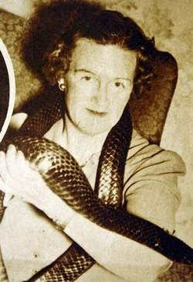
A picture of Nancy Sposato's grandmother Eugenia Shorrock with a snake from her Alton Bay Reptile Zoo that appeared in a Boston Herald newspaper November 16, 1941
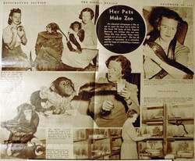
A picture page from a November 16, 1941 Boston Herald article on Nancy Sposato's grandmother Eugenia Shorrock and her Alton Bay Reptile Zoo.

